**Creating a project in IntelliJ**

Contents

A. Web application with Thymeleaf 1

Create template for Thymeleaf 2

Structure of MVC 3

B. Web application with Thymeleaf and JPA 5

## Web application with Thymeleaf

1. File > New > Project...
2. Choose Spring Initializr and choose a name for your project (e.g. *firstexample*)  
   Choose the location where you want your project to be saved. Note that if you choose a new Location (by browsing) you have to repeat the name of your project at the Location (at the end).   
   For "Group" always fill in *fact.it*. Make sure you mark the *Project SDK* 17 (and Java 17).

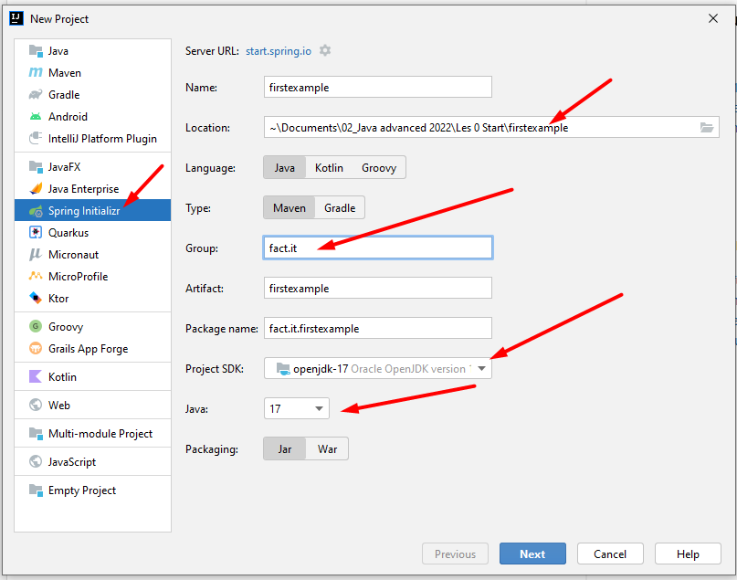

1. Choose Web and Spring Web + Template Engines and Thymeleaf

1. Click Finish
2. 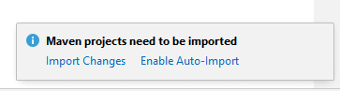You may get this window. Then click ***Enable Auto-Import***.

### Create template for Thymeleaf

You probably already have this from last academic year 1ITF Java. But if you don't have it (yet), do the following:

1. From the menu, select File > Settings > Editor > File and Code Templates.
2. Click on and enter 'Thymeleaf HTML file' , as extension 'html' and enter the following code

<!DOCTYPE html>

<html lang="en" xmlns:th="http://www.thymeleaf.org">

<head>

<meta http-equiv="Content-Type" content="text/html; charset=UTF-8">.

<title>Title</title>

</head>.

<body>.

Body content

</body>

</html>.

1. Click on ok

### Structure of MVC

1. 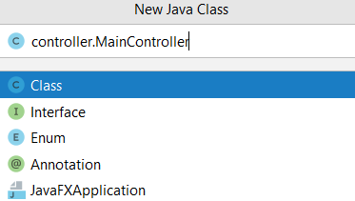Controller

* In the project overview, go to src > main > java > fact.it.yourproject
* Right-click and choose New > Java Class
* Name that class controller.MainController and press Enter
* Add the annotation @Controller at the top of MainController: **@Controller** and make the mappings

**package** fact.it.vbthymeleaf.controller;  
  
**import** org.springframework.stereotype. Controller;  
**import org.**springframework.ui.Model;  
**import org.**springframework.web.bind.annotation. RequestMapping;  
  
@Controller  
**public class** MainController { @RequestMapping(**"/"**) **public** String studentInfo(Model model){ model.addAttribute(**"firstname"**, **"Kristine"**); **return "studentinfo"**;   
}}

1. Model

* You create the classes in the package *model*, which is located under fact.it.yourproject, as before.

1. View layer

* In the Project Overview, go to src > main > resources > templates
* Right click and choose New > Thymeleaf HTML file> choose a name

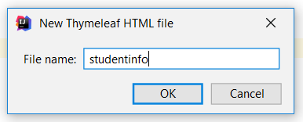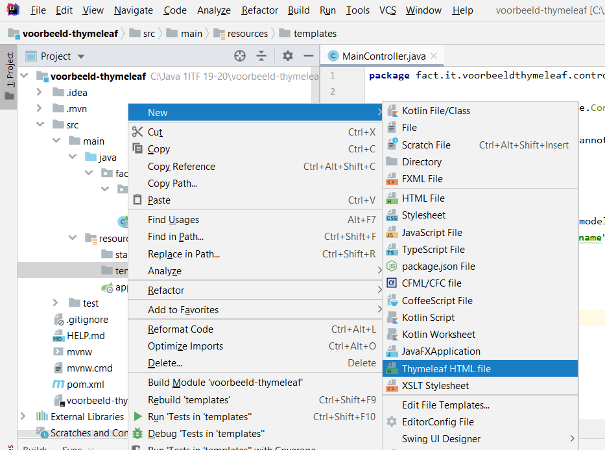

* The Thymeleaf template appears. Complete.
* Click on run 
* **Go to browser and enter "http://localhost:8080" as URL.**

## Web application with Thymeleaf and JPA (from lesson 3!)

Follow steps 1 to 6 of A. Creating a web application with Thymeleaf (A).

1. Then click on SQL in the left column and in the middle column choose   
   **Spring Data JPA**
2. And lower in the same list, click on **MySQL Driver**.

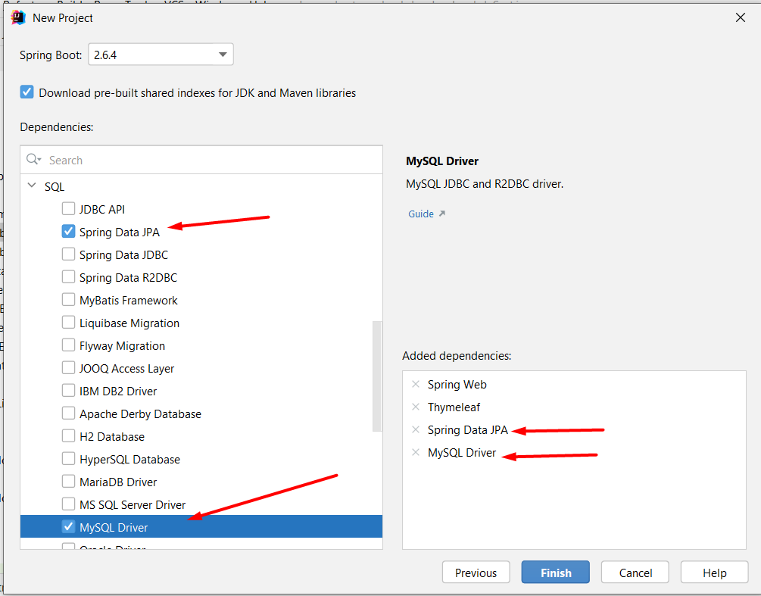

1. Finally, click next and finish...
2. Put the following code in your application.properties file

**spring.datasource.url=jdbc:mysql://localhost:3306/lesson?serverTimezone=UTC  
spring.datasource.username=admin  
spring.datasource.password=sql**

**spring.jpa.hibernate.use-new-id-generator-mappings= false**

1. Add the following code in your application.properties file depending on the situation
   1. If you want to start from a "clean slate" and delete the existing tables with the content from the start of your application, add the following code

**spring.jpa.hibernate.ddl-auto=create-drop**

* 1. However, if you want to continue working on the tables already in your database, replace the above code with:

**spring.jpa.hibernate.ddl-auto=none**